**Getting Familiar with Simulink**

**Lab Report #12**

Spring 2022

CSE301 - L

Signals & Systems Lab

Submitted by:

Hamid Ur Rehman

Registration#:

20PWCSE1969

Class Section:

C

“On my honor, as student of Engineering and Technology, I have neither given nor received unauthorized assistance of this academic work”.

**Submitted to:**

Engr. Durr-e-Nayab

7/16/2022

Getting Familiar with Simulink

**What is Simulink:**

Simulink is an extension to MATLAB. In Simulink, you build block diagram models of dynamic systems instead of text code. It is easy to model complex nonlinear systems. Simulink can model both continuous and discrete-time components.

Lab Objectives

This lab aims at the understanding of:

* Basics of Simulink
* Creation of simple model in Simulink
* Understanding of tools.
* Usage of tools in a task

Etc.

**Task:**

Real Time ECG QRS Detection:

This example shows how to detect the QRS complex of electrocardiogram (ECG) signal in real-time. Model based design is used to assist in the development, testing and deployment of the algorithm.

**Introduction:**

The electrocardiogram (ECG) is a recording of body surface potentials generated by the electrical activity of the heart. Clinicians can evaluate an individual's cardiac condition and overall health from the ECG recording and perform further diagnosis.

Baseline wander

Power line interference (50 Hz or 60 Hz)

Electromyographic (EMG) or muscle noise

Artifacts due to electrode motion

Electrode Contact Noise

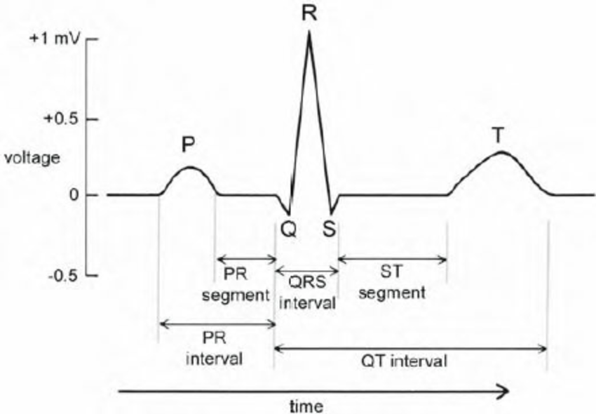

ECG Signal Processor:

The ECG signals used in the development and testing of the biomedical signal processing algorithms are mainly from three sources:

1) pre-recorded ECG data

2) ECG simulator

3) Real-time ECG data acquisition.

In this task, the following pre-recorded and simulated ECG signals are used. The signals all have sampling frequencies of 360 Hz.

One set of recorded real ECG data sampled from a healthy person with a mean heart rate of 82 beats per minute (bpm). This ECG data was pre-filtered and amplified by the analog front end before feeding it to the 12 bit ADC.

Four sets of synthesized ECG signals with different mean heart rates ranging from 45 bpm to 220 bpm. [ECGSYN](http://www.physionet.org/physiotools/ecgsyn/) is used to generate synthetic ECG signals in MATLAB.

Here are the settings for generating the synthesized ECG data:

Sampling frequency: 360 Hz;

Additive uniformly distributed measurement noise: 0.005 mV;

Standard deviation of heart rate : 1 bpm.

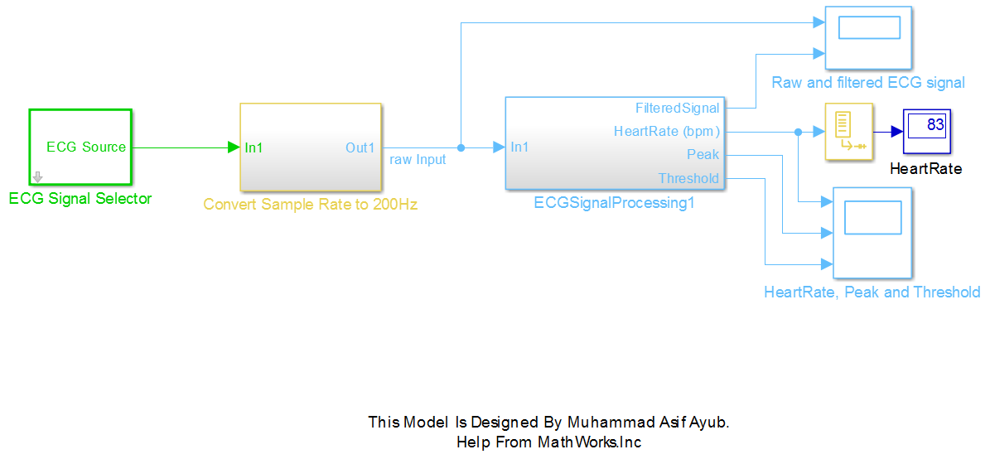

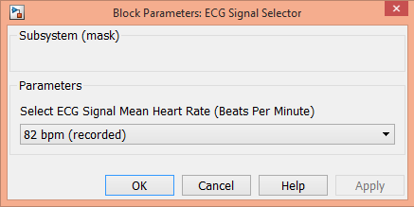

ECG Signal Pre-processing and Filtering:

A real-time QRS detection algorithm, which references [1, lab one], [3] and [4], is developed in Simulink with the assumption that the sampling frequency of the input ECG signal is always 200 Hz (or 200 samples/s). However, the recorded real ECG data may have different sampling frequencies ranging from 200 Hz to 1000 Hz, e.g., 360 Hz in this example. To bridge the different sampling frequencies, a sample rate converter block is used to convert the sample rate to 200 Hz. A buffer block is inserted to ensure the length of the input ECG signal is a multiple of the calculated decimation factor of the sample-rate converter block.

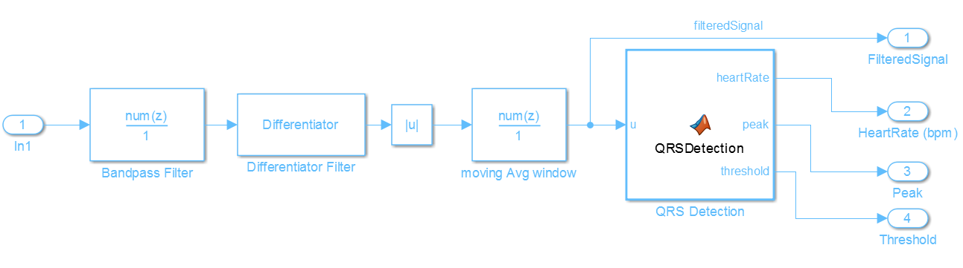

**Real-Time QRS Detection of ECG Signal:**

The QRS detection block detects peaks of the filtered ECG signal in real-time. The detection threshold is automatically adjusted based on the mean estimate of the average QRS peak and the average noise peak. The detected peak is classified as a QRS complex or as noise, depending on whether it is above the threshold.

The following QRS detection rules reference the PIC-based QRS detector implemented in.

Ignore all peaks that precede or follow larger peaks by less than 196 ms (306bpm).

If a peak occurs, check to see whether the raw signal contains both positive and negative slopes. If true, report a peak being found. Otherwise, the peak represents a baseline shift.

If the peak is larger than the detection threshold, classify it as a QRS complex. Otherwise classify it as noise.

If no QRS has been detected within 1.5 R-to-R intervals, but there is a peak that was larger than half the detection threshold, and that peak followed the preceding detection by at least 360ms, classify that peak as a QRS complex.

Simulate and Deploy:

On the model tool strip, click Run to start the simulation. Observe the Heartrate display and the raw and filtered ECG signal in the scope, which also illustrates the updating of peaks, threshold and estimated mean heart rate.

Open the dialog of ECG Signal Selector block. Select the ECG signal mean heart rate in the drop down menu. Click Apply and observe the real-time detection results in the scopes and Heartrate display.

Click Stop to end simulation.

After selecting target hardware, you can generate code from the ECGSignalProcessing subsystem and deploy it to the target.

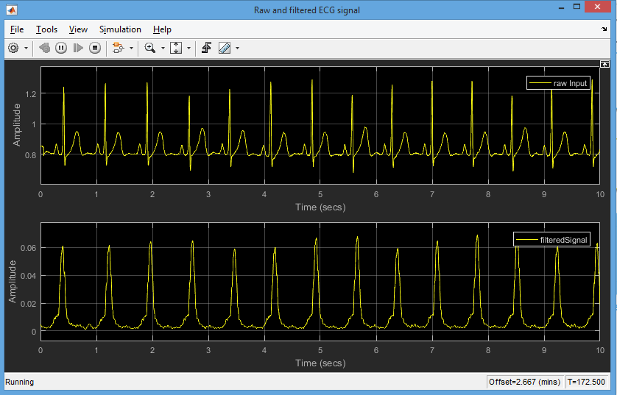

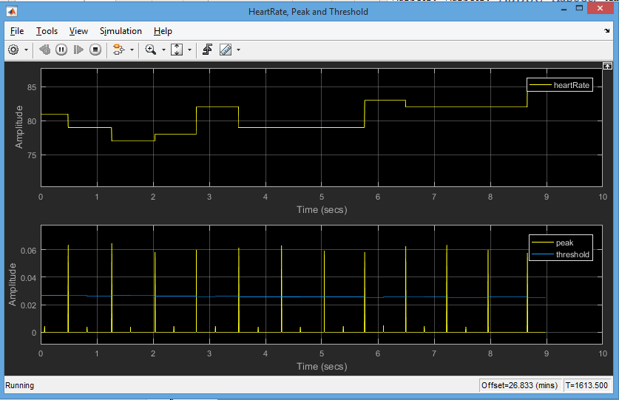

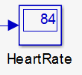This Simulation is Real Time for infinite interval of time we can change its specification whatever we want to.

So it will tell us the heart rate of ECG signal using peaks of ECG.

It means that it counts the distance between two peaks for such interval of time to examine the heart rate of any body or we can give it an artificial input as well.

THE END